CS510 HW10

1. 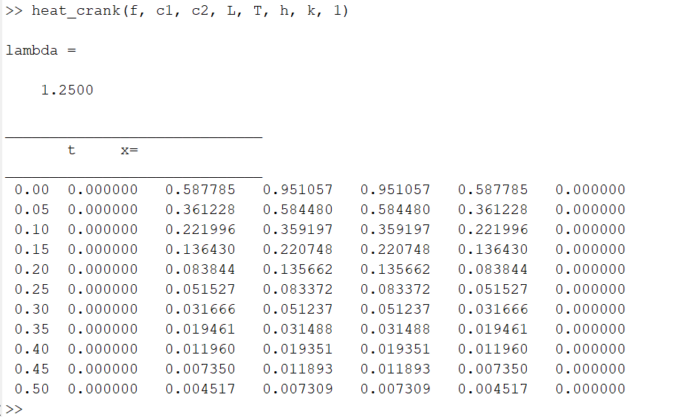
2. Q1
3. 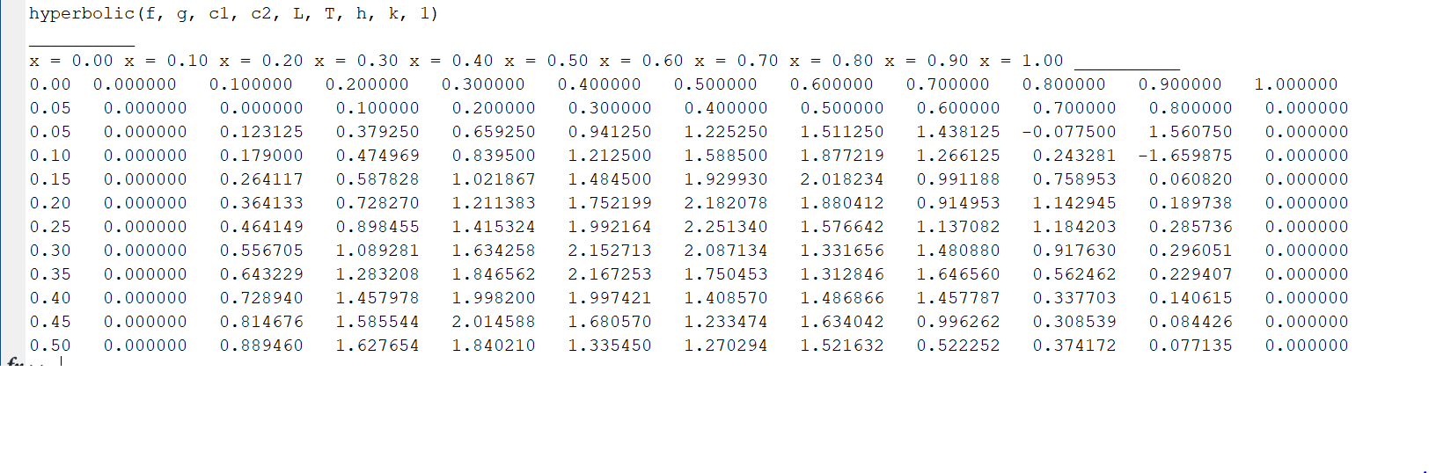
4. Wave Funciton
   1. 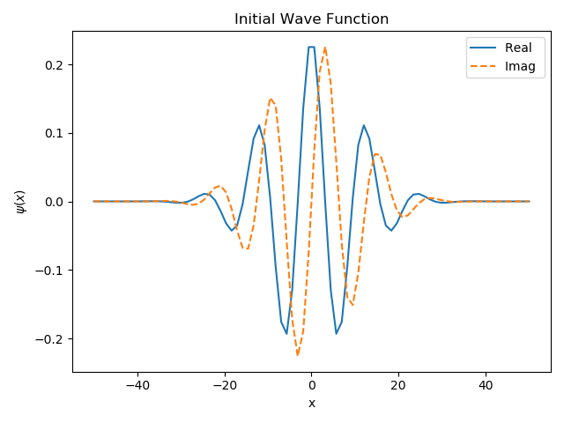
   2. pr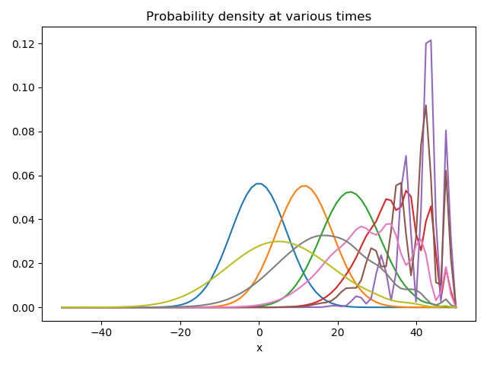
   3. The graph in (b) appear to be a more realistic version interpretation of the properties of the motion of a wave. This is primarily due to the change in probability density over time being more accurately representative of where the particle will exist at a given time, despite following the same wave function shifted over time.